Enhancing road safety with ai driven traffic accident analysis and prediction:-

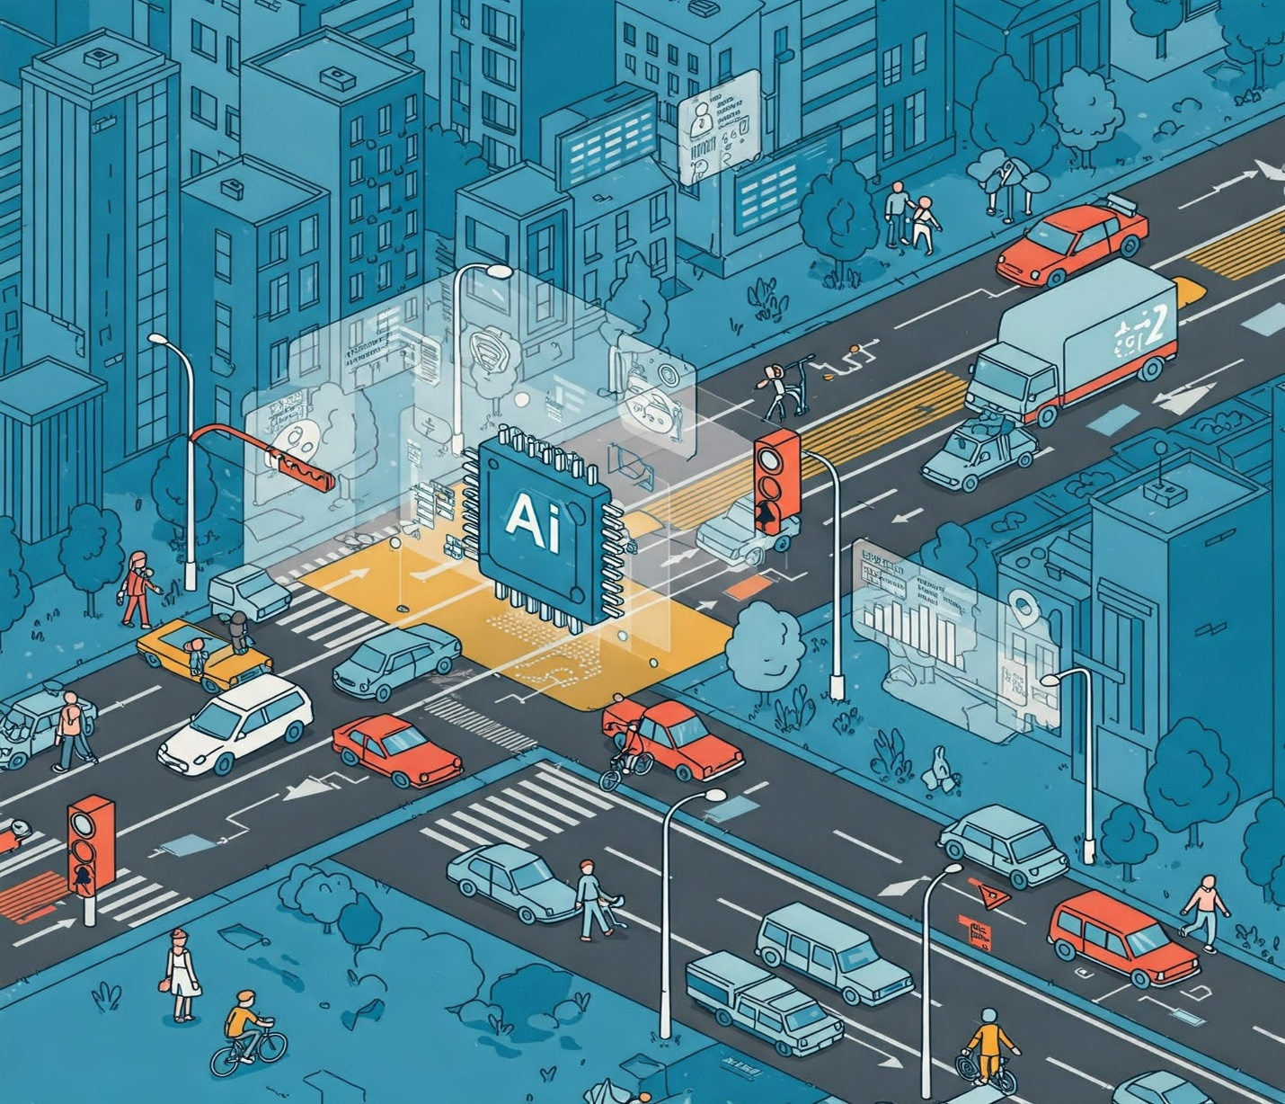

**NAME:** SUJITHRA M

**REG.NO:** 422623106001

**INSTITUTION:** University College Of Engineering Panruti

**DEPARTMENT:** Electronics And Communication Engineering

**DATE OF SUBMISSION:** 26.04.2025

**Problem Statement:**

Traditional methods for analyzing and forecasting traffic accidents frequently fail to capture the complex, nonlinear relationships among the diverse factors influencing accident occurrence and severity. Despite the growing availability of large-scale traffic, environmental, and behavioral data, current road safety interventions remain largely reactive rather than proactive. Road traffic accidents are a major global public health and socioeconomic challenge, resulting in over 1.19 million fatalities annually and significant economic losses.

There is a critical need for advanced, AI-driven solutions that can:

* Predict the likelihood, frequency, and severity of road traffic accidents using machine learning models trained on heterogeneous data sources (e.g., temporal, environmental, infrastructural, and behavioural factors).
* Identify high-risk locations, time periods, and contributing factors to enable targeted, data-driven interventions and resource allocation.
* Provide explainable insights to policymakers and stakeholders, facilitating the translation of model predictions into effective safety measures and policies.

The challenge lies in developing robust, interpretable AI models that not only achieve high predictive accuracy but also uncover actionable patterns and causal relationships within complex traffic accident data, ultimately enabling proactive strategies to reduce accident rates and enhance road safety for all users.

**Objectives of the Project:**

1. **Predict Accident Risk and Severity:**Develop machine learning models (e.g., Random Forest, ensemble methods) to forecast the likelihood, frequency, and severity of traffic accidents using heterogeneous data sources such as historical accident records, weather conditions, traffic flow, and road infrastructure. These models aim to achieve high accuracy (e.g., >85% precision) in identifying high-risk zones and times**.**
2. **Identify Contributing Factors:**Analyse spatial, temporal, and environmental variables (e.g., road geometry, weather, driver behaviour) to determine root causes of accidents and quantify their impact on risk levels. For example, prioritize factors like low visibility or sharp turns in accident-prone areas.
3. **Enable Proactive Interventions:**Create real-time prediction systems to alert authorities and drivers about emerging risks, allowing timely deployment of emergency services or traffic rerouting. Integrate with platforms used by traffic management agencies and navigation apps.
4. **Optimize Resource Allocation:**Provide actionable insights for policymakers to prioritize infrastructure upgrades (e.g., adding signage in high-risk areas) and allocate budgets effectively. Measure success through reduced accident rates (e.g., 20% decline in fatalities within 2 years).
5. **Enhance Explainability and Transparency:**Implement interpretable AI techniques to clarify model decisions for stakeholders, ensuring trust and facilitating evidence-based policy changes.
6. **Improve Data Integration and Visualization:**Aggregate disparate datasets (traffic cameras, weather APIs, police reports) into a unified system and visualize risk hotspots via interactive dashboards.

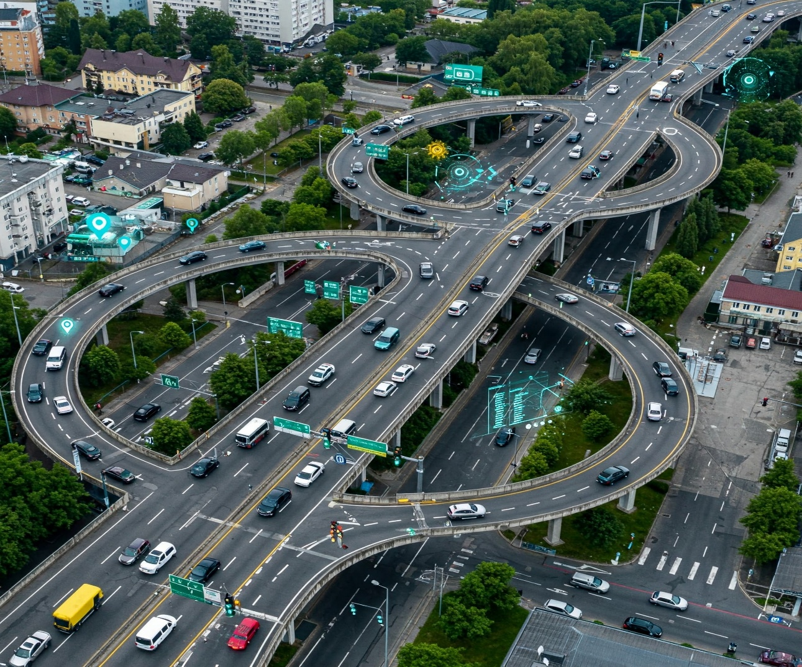

**Scope of the Project:**

**1. Data Integration and Preprocessing:**

* Aggregate heterogeneous datasets including historical accident reports, real-time traffic flow, weather conditions, road infrastructure details (e.g., geometry, signage), and behavioral data (e.g., speeding violations) .
* Incorporate IoT and connected vehicle data (e.g., sensor readings, GPS trajectories) for dynamic risk assessment, as demonstrated in Sweden's AI Aware project.

**2. Model Development and Validation:**

* Implement ensemble learning techniques (e.g., Random Forest, Gradient Boosting) and deep learning architectures (e.g., CNNs, autoencoders) to predict accident risk, frequency, severity, and duration.
* Prioritize explainability through techniques like SHAP values or rule-based systems to identify key factors (e.g., low visibility, sharp turns).

**3. Real-Time Prediction Systems:**

* Develop API-driven platforms for issuing alerts to drivers, traffic management centers, and emergency services during high-risk conditions .
* Integrate with navigation apps to reroute traffic dynamically based on predicted accident hotspots.

**4. Stakeholder Collaboration:**

* Enable cross-agency coordination (e.g., police, road authorities, healthcare) through shared dashboards visualizing risk maps and intervention priorities.
* Align with initiatives like the WHO’s 2030 road safety targets by providing data-driven policy recommendations.

**5. Proactive Interventions:**

* Optimize infrastructure upgrades (e.g., adding traffic lights at high-risk intersections) and enforcement strategies (e.g., targeted patrols).
* Measure success through metrics like reduced fatalities (e.g., 20% decline over two years) and improved emergency response times

**Data Sources:**

**1. Historical Accident Data:**

* Official accident reports from police, transportation departments, and insurance agencies provide detailed records of past incidents, including location, time, severity, and contributing factors**.**

**2. Traffic Flow and Road Attribute Data:**

* Real-time and historical traffic flow statistics (vehicle counts, speed, congestion levels) are essential for understanding dynamic risk patterns.
* Road attributes include geometry, signage, lane markings, and surface conditions, often sourced from government databases or programs like iRAP.

**3. Geospatial and Environmental Data:**

* Geo-located crash data and multi-dimensional geospatial attributes (e.g., angular, directional features) help map and analyze accident hotspots.
* Weather conditions (rain, fog, temperature, visibility) are integrated from meteorological services to assess their impact on accident risk.

**4. Video and Image Data:**

* Datasets from traffic surveillance cameras, dashcams, drones, and building-mounted cameras capture real-time and historical footage for computer vision-based detection and analysis.
* These video datasets are often annotated with accident types (e.g., rear-end, frontal, side-hit) and normal traffic scenarios, enabling deep learning models to learn from diverse situations.

**5. Connected Vehicle and IoT Data:**

* Data from vehicle sensors, GPS devices, and vehicle-to-infrastructure (V2I) systems provide granular, real-time information on vehicle behavior and interactions, supporting dynamic risk assessment**.**

**6. Social Media and Crowd-Sourced Data:**

* Time-sensitive reports and alerts from social media platforms and mobile apps can supplement official data, especially for real-time incident detection and response.

**7. Publicly Available Benchmark Datasets:**

* Examples include the TAP (Traffic Accident Prediction) repository covering 1,000 US cities and 49 states, and the Global Traffic Accidents Dataset with records from various countries.

**High-Level Methodology:**

**1. Data Collection and Integration:**

* Gather heterogeneous data from multiple sources: historical accident records, traffic flow, weather, road infrastructure, geospatial attributes, and video feeds.
* Clean, preprocess, and integrate data to handle missing values, inconsistencies, and class imbalance (e.g., using techniques like SMOTE).

**2. Feature Engineering and Selection:**

* Extract and select relevant features such as time of accident, location, road type, weather, vehicle type, and traffic conditions.
* Engineer new features (e.g., temporal patterns, spatial clusters, motion templates from video) to enhance predictive power.

**3. Model Development:**

* Train and evaluate a suite of machine learning models (e.g., Logistic Regression, Random Forest, Gradient Boosting, LightGBM, Neural Networks) to predict accident occurrence, severity, or fatality.
* For video and real-time data, apply deep learning models (e.g., CNNs, LSTMs, DNNs) for accident detection and prediction.
* Address class imbalance and optimize hyperparameters for best performance.

**4. Model Evaluation and Validation:**

* Assess models using metrics such as precision, recall, F1-score, ROC-AUC, and accuracy.
* Perform cross-validation and test on unseen data to ensure generalizability.

**5. Model Interpretability and Insights:**

* Apply explainable AI techniques (e.g., SHAP values, rule-based models) to identify key contributing factors and enhance transparency for stakeholders.
* Visualize and communicate influential features such as casualty class, time, location, vehicle type, and road type.

**6. Real-Time Prediction and Deployment:**

* Integrate models into real-time systems for proactive risk alerts, emergency response, and dynamic traffic management.
* Develop APIs and dashboards for visualization and stakeholder engagement.

**7. Continuous Improvement:**

* Monitor model performance, update with new data, and refine features and algorithms as needed.
* Incorporate feedback from end-users and stakeholders to enhance system relevance and effectiveness.
* This methodology ensures a comprehensive, data-driven, and actionable framework for enhancing road safety through AI-powered accident analysis and prediction.

**Tools and Technologies:**

* **Programming Language:** Python .
* **Development Environment:** Jupiter Notebook or Google colab.
* **Data Libraries:** Pandas ,NumPy .These handle loading and preprocessing of datasets.
* **Machine Learning:** Scikit-learn , TensorFlow/Keras. These libraries enable model training and evaluation.
* **Data Visualization:** Matplotlib and Seaborn, Plotly Folium or GeoPandas could be used for mapping accident locations.
* **Deployment Framework:** Flask, Streamlit, or FastAPI. These lightweight Python frameworks help create a web app or dashboard to showcase the predictive model and visualizations.
* **Optional Tools:** Git for version control; Google Colab or cloud services for computing if data is large. For GIS data, libraries like Shapely or Geopandas could be used.

**Team Members and Roles :**

1. **SUJITHRA M** :Project Lead : Oversees the entire project, coordinates tasks, and ensures deadlines are met.

2.**SUBASHINI S**: Handles data collection, cleaning, and exploratory data analysis.

3**. MARIYA MOUNIYA A**: Focuses on building and training the AI models for accident prediction.

4.**REKA R**: Manages data storage, preprocessing, and feature engineering.

5.**NITHYASRI N**: Works on deploying the AI model into a web application and ensures it runs smoothly.